Electronics Documentation

1. Electronics Block Diagram

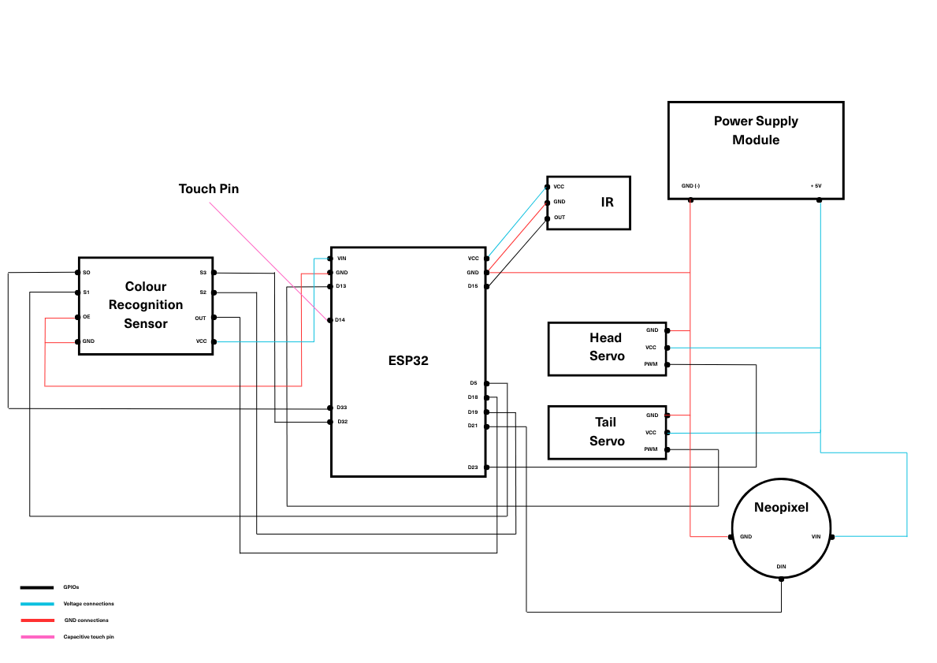

2. Components Table
Component | Quantity | Purpose | Justification
Servo Motor | 2 | One to move the head, and another to wag its tail | Short angles are required for this application and hence servo motor
IR sensor | 1 | To detect to presence of a person for the chameleon to move its head | Easier to control the sensitivity - can detect people from a short distance (placed near our rock structure)
Neopixel | 1 | To showcase colours on its body | Want the chameleon to do its main attribute, i.e, camouflage, so need of different colours
Colour detector sensor module | 1 | Detect colours for the neopixel to turn that colour | Want the chameleon to do its main attribute, i.e, camouflage, so need to detect nearby colours
Esp32 | 1 | To make our sensors and pins work | Running code through Thonny with esp32 as a module
Power supply module | 1 | To make our neopixel and servo motors work | External power supply needed to run heavier load things like motors
Touch Pin | 1 | “Shaking hand” movement attached to the hand, which would make the tail wag | Needed a touch-sensitive interactive part

